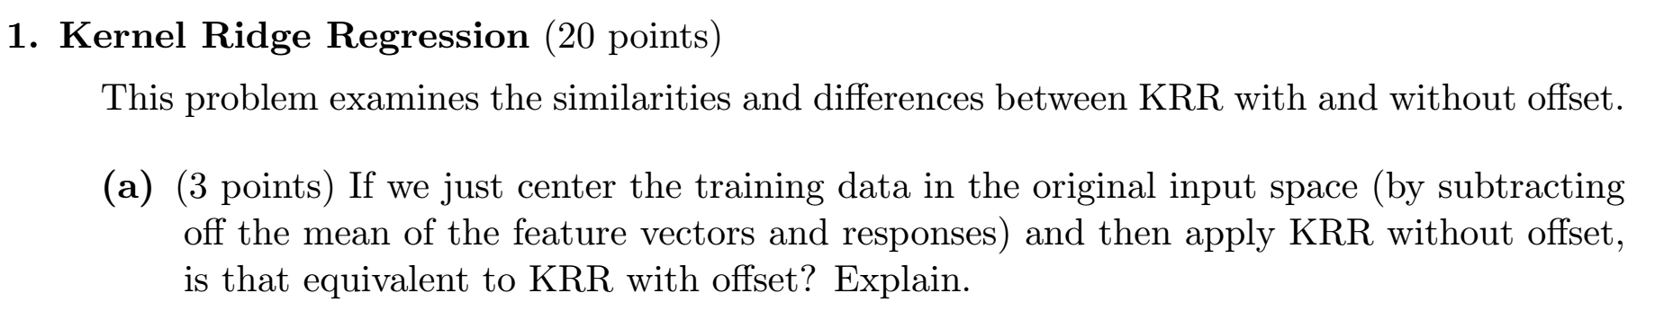

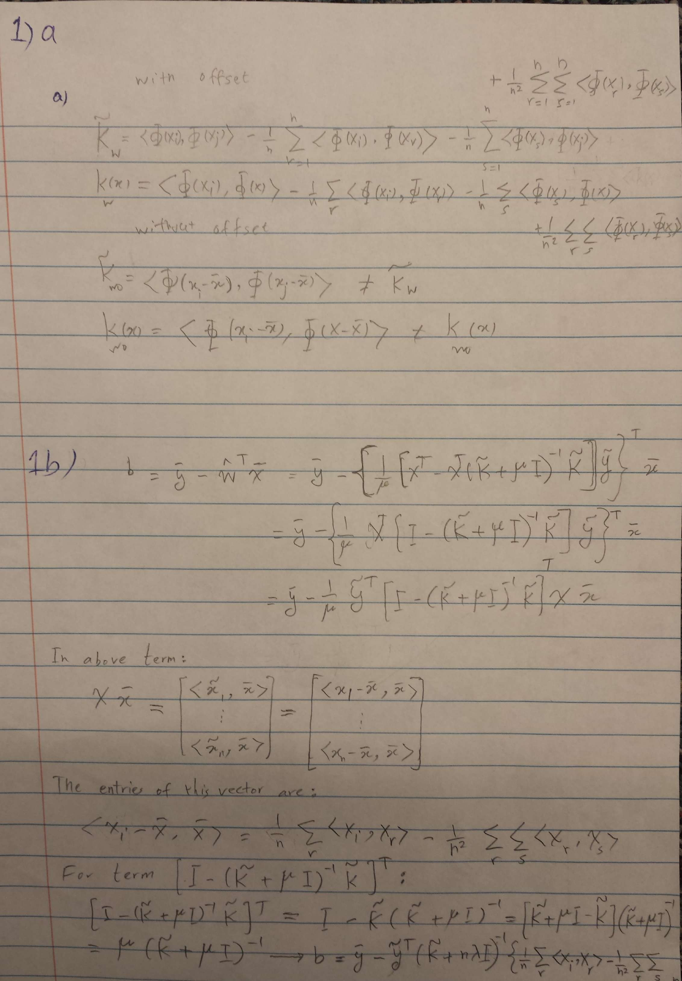





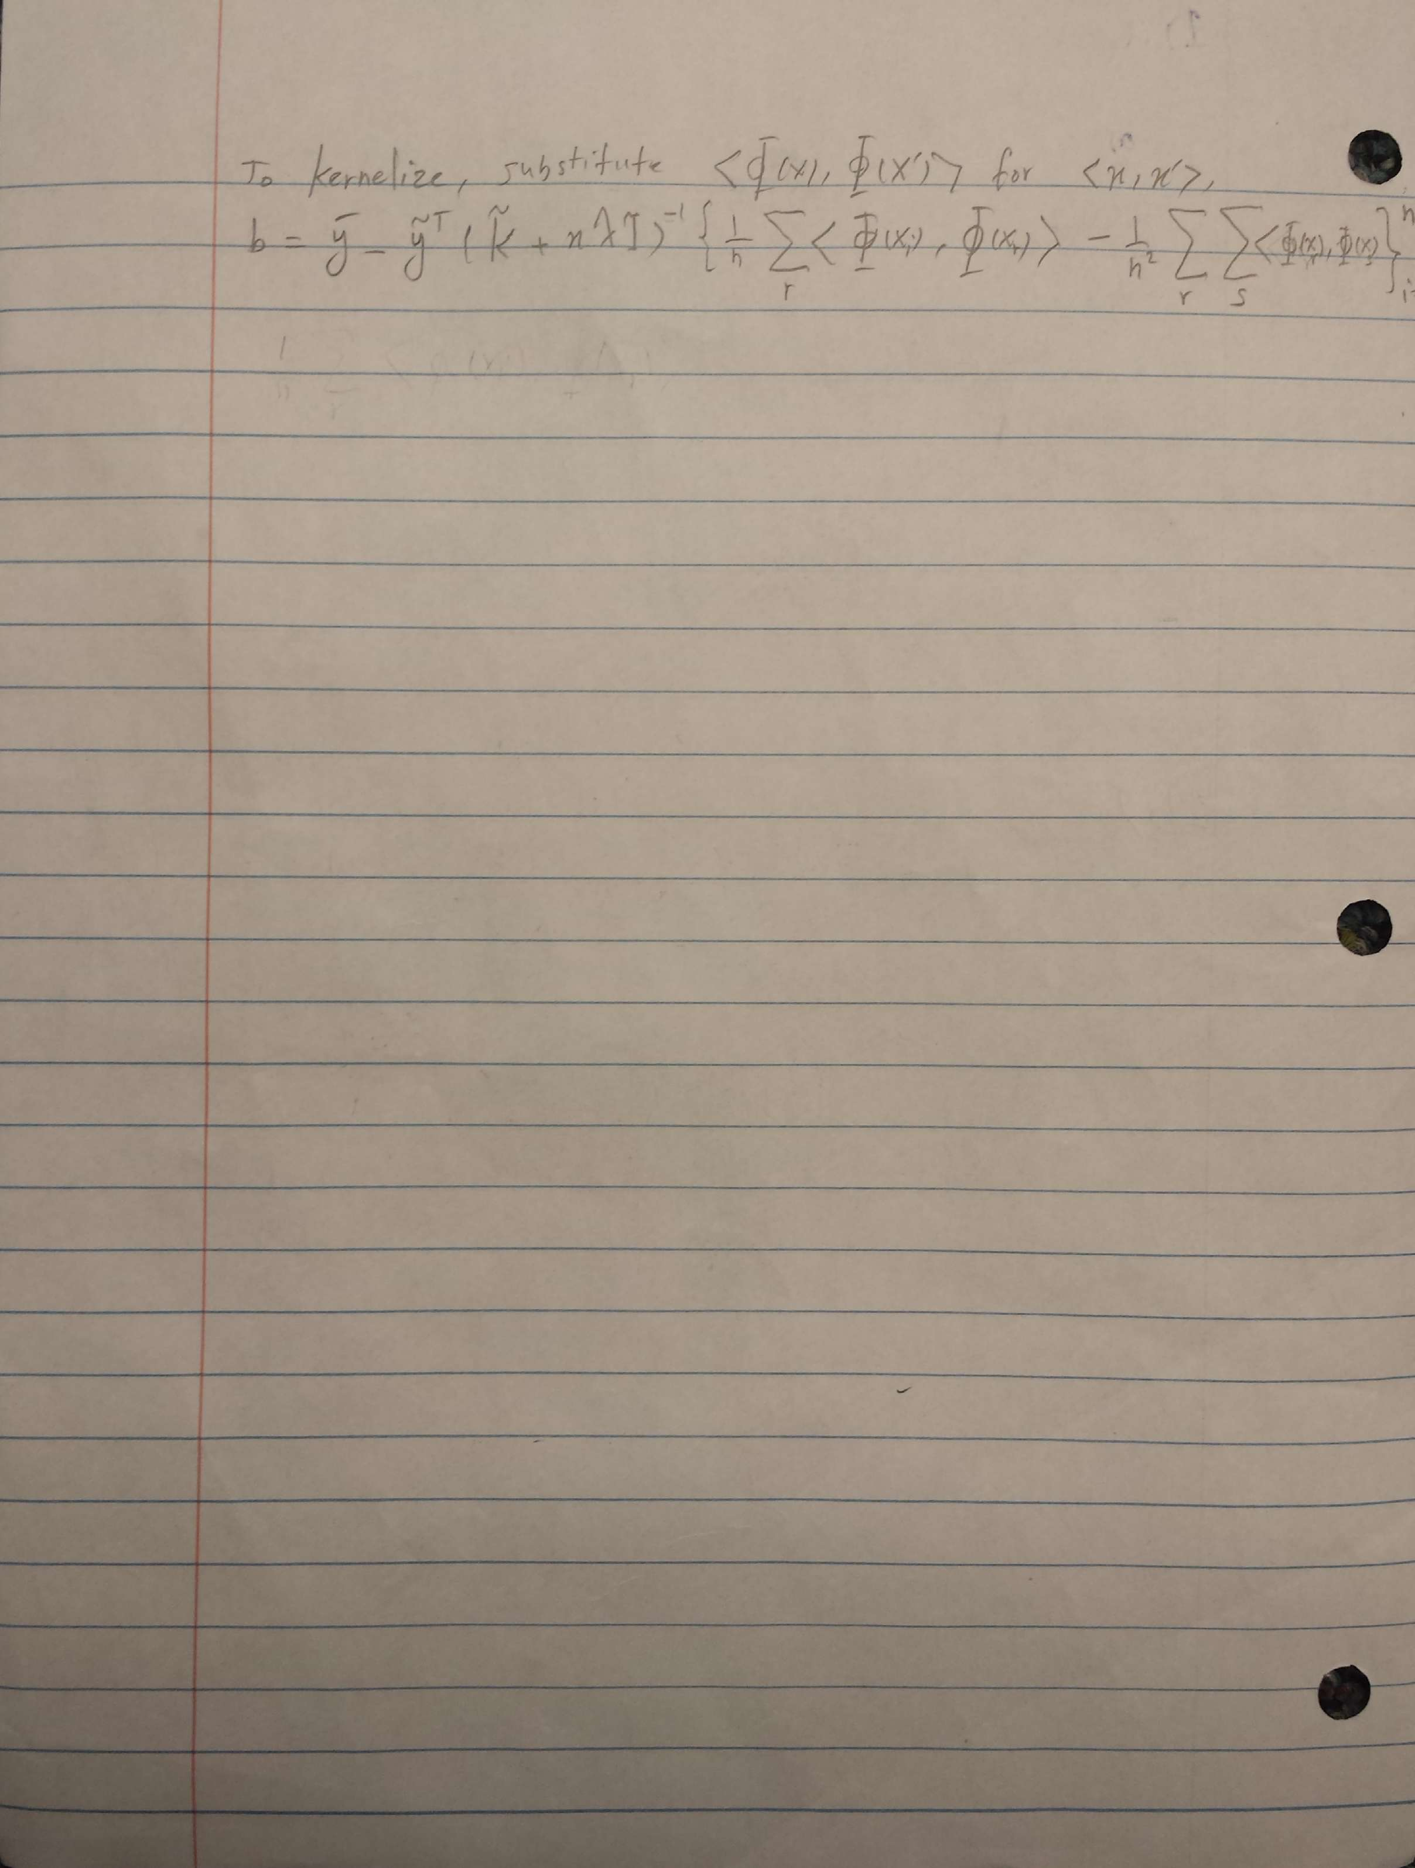

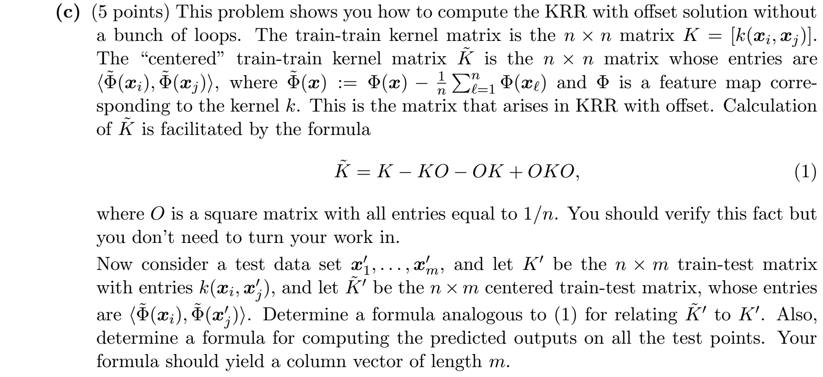

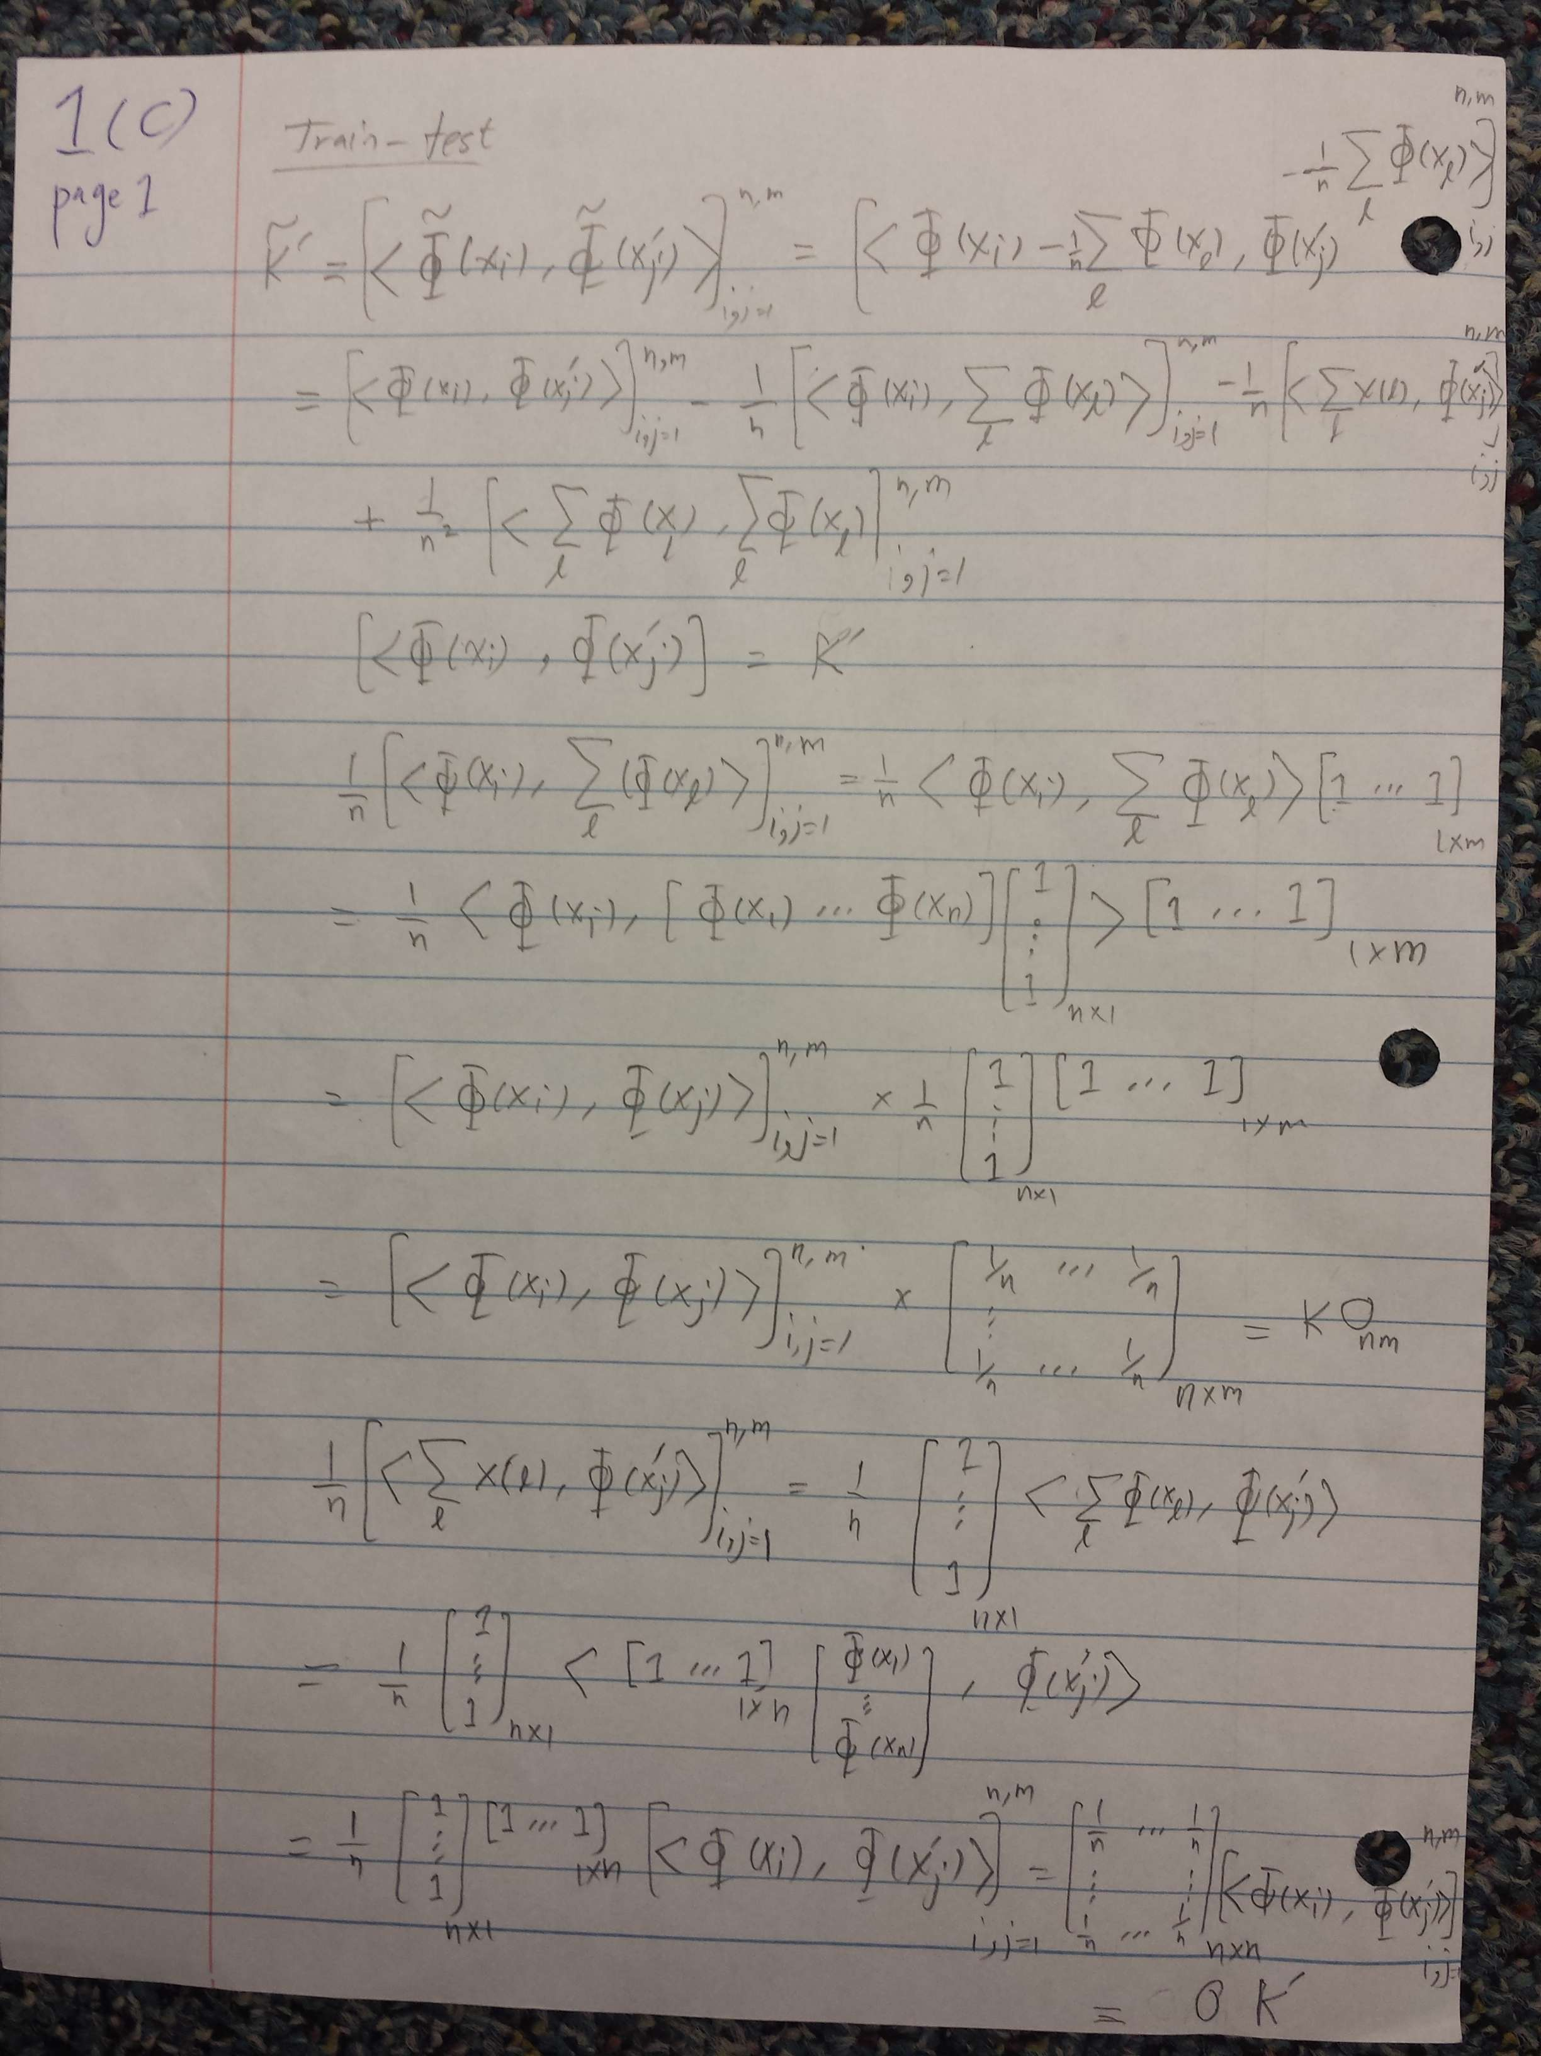

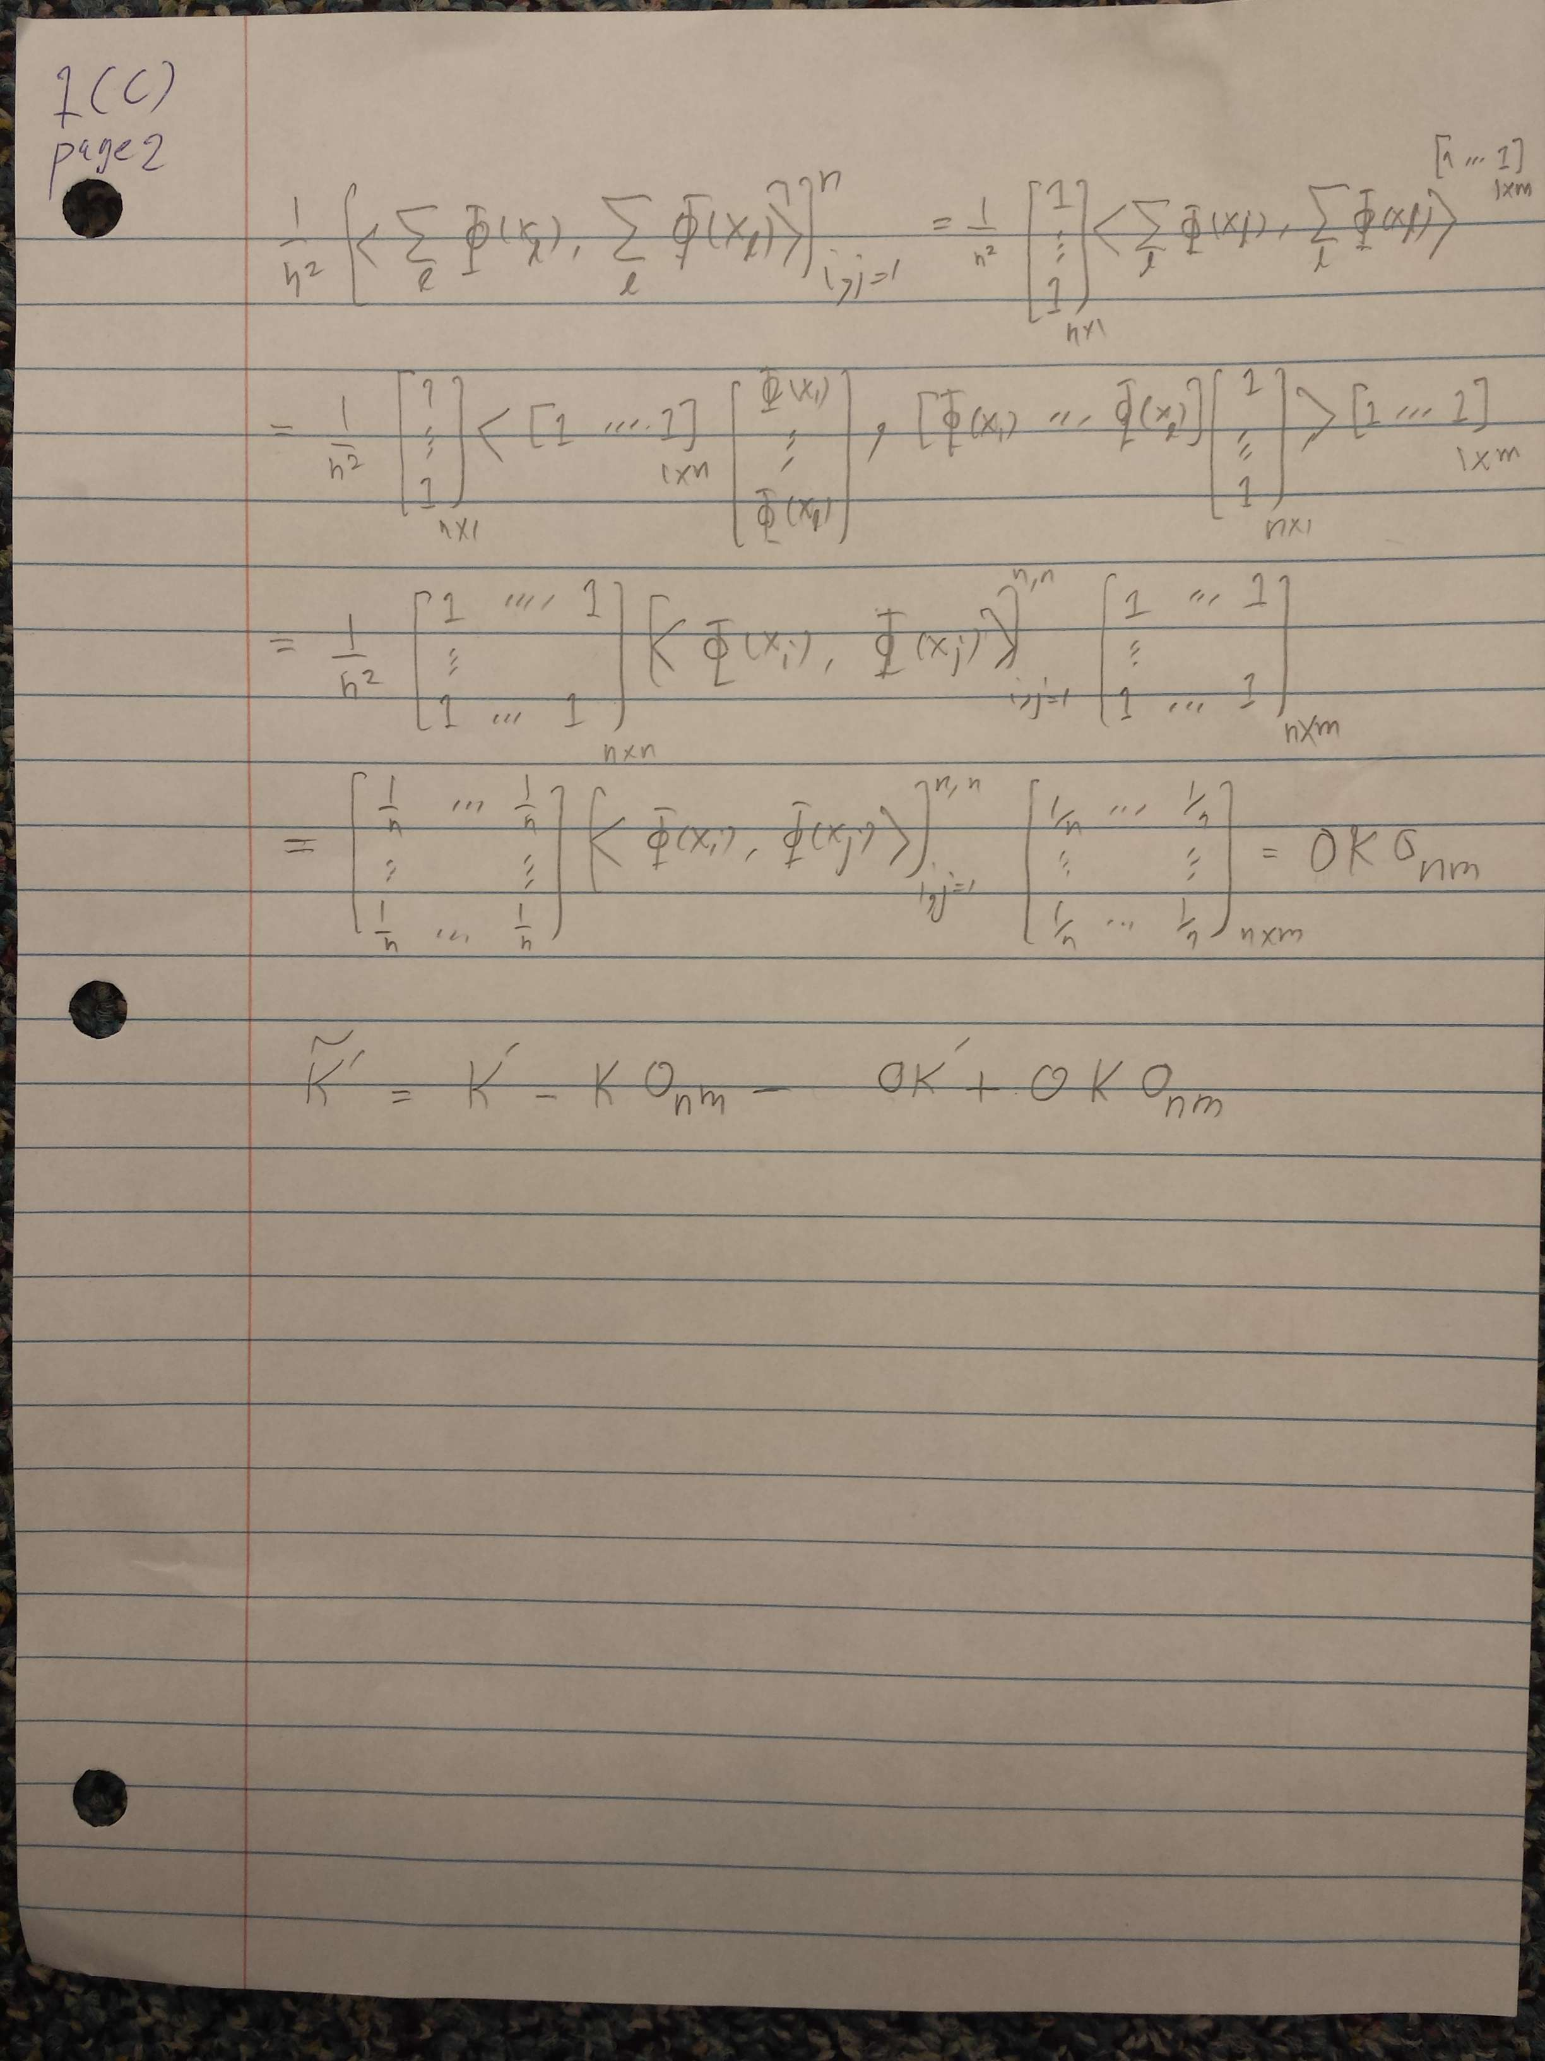

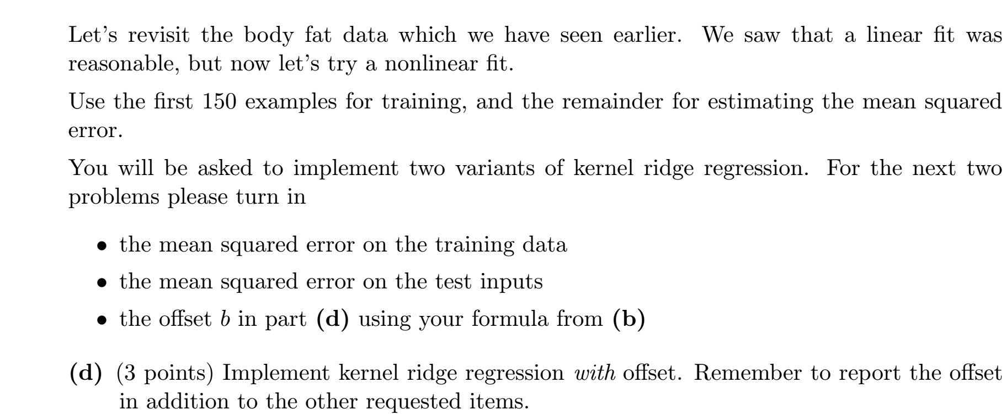

MSE_training= 28.7940, MSE_test= 34.1488, b=1.0314

Code for KRR with offset:

|  |
| --- |
| close all; clear all; clc  load bodyfat_data.mat  n=150;  lambda=3e-3;  d=2;  x_train=X(1:n,:);  y_train=y(1:n);  x_test=X(n+1:end,:);  y_test=y(n+1:end);  m=numel(y_test);  xbar=sum(x_train,1)/n;  ybar=sum(y_train)/n;  xtilde=x_train-repmat(xbar,[n 1]);  ytilde=y_train-ybar;  O=1/n*ones(n);  for i=1:n  for j=1:n  K(i,j)=gaus_ker(x_train(i),x_train(j));  end  end  Ktilde=K-K*O-O*K+O*K*O;  yhat_train=ybar+ytilde'*(Ktilde+n*lambda*eye(n))^-1*Ktilde;  yhat_train=yhat_train';  e_train=y_train-yhat_train;  MSE_train=sum(e_train.^2)/98  for i=1:n  for j=1:m  Kprime(i,j)=gaus_ker(x_train(i),x_test(j));  end  end  Onm=1/n*ones(n,m);  Ktildeprime=Kprime-K*Onm-O*Kprime+O*K*Onm;  yhat_test=ybar+ytilde'*(Ktilde+n*lambda*eye(n))^-1*Ktildeprime;  yhat_test=yhat_test';  e_test=y_test-yhat_test;  MSE_test=sum(e_test.^2)/98  b=ybar-ybar-ytilde'*(Ktilde+n*lambda*eye(n))^-1*(1/n*sum(K,2)-(1/n^2)*sum(K)*ones(n,1)) |

Code for calculation of Gaussian kernel:

|  |
| --- |
| function k=gaus_ker(u,v)  sigma=1.5;  k=exp(-1/(2*sigma^2)*norm(u-v)^2);  end |

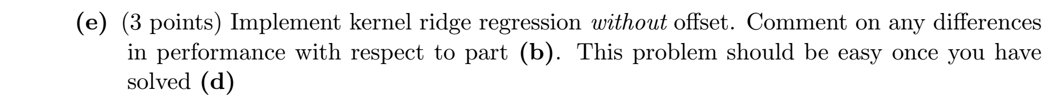

MSE_training=28.8242, MSE_test=73.9540

Code for KRR without offset:

|  |
| --- |
| close all; clear all; clc  load bodyfat_data.mat    n=150;  lambda=3e-3;  d=2;    x_train=X(1:n,:);  y_train=y(1:n);    xbar=sum(x_train,1)/n;  ybar=sum(y_train)/n;    xtilde=x_train-repmat(xbar,[n 1]);  ytilde=y_train-ybar;    %%%%%%%%% Ktilde %%%%%%%%  for i=1:n  for j=i:n  sum2=0;  for r=1:n  sum2=sum2+gaus_ker(x_train(i),x_train(r));  end  sum3=0;  for s=1:n  sum3=sum3+gaus_ker(x_train(s),x_train(j));  end  sum45=0;  for r=1:n  for s=1:n  sum45=sum45+gaus_ker(x_train(r),x_train(s));  end  end  Ktilde(i,j)=gaus_ker(x_train(i),x_train(j))-1/n*sum2-1/n*sum3+1/n^2*sum45;  Ktilde(j,i)=Ktilde(i,j);  end  end  %%%%%%%%%%%%%%%%%%%%%%%%%%%%%%%    x_test=X(n+1:end,:);  y_test=y(n+1:end);    for i=1:numel(y_test)  yhat_test(i)=ybar+ytilde'*(Ktilde+n*lambda*eye(n))^-1*ktilde(x_test(i));  end  e=y_test-yhat_test;  MSE=sum(e.^2)/98 |

